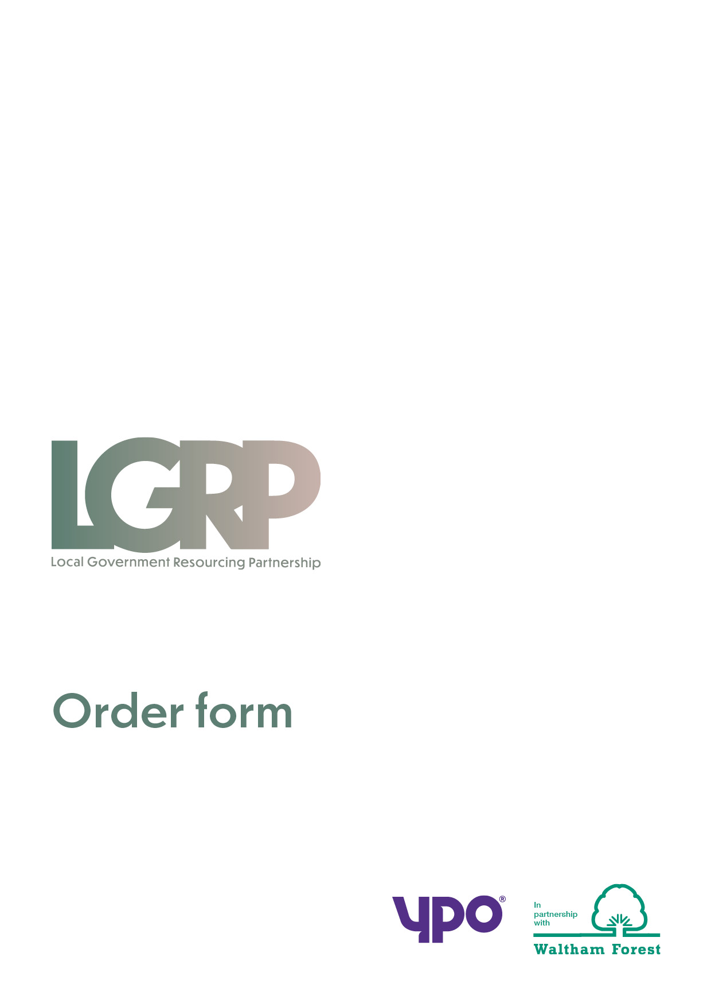
ORDER FORM AND CALL-OFF CONTRACT
FRAMEWORK AGREEMENT LGRP 1030
FROM
Customer
Address
Invoice address
Contact ref: | Ref:  Name:  Phone:  e-mail:
TO
Provider:
Address:
Contact details | Name:  Phone:  Email

      - TERM

  - Effective date
    - This Call-Off Contract shall commence on:
    - Service commencement date:

  - Expiry date

    - This Call-Off Contract shall expire on:

    - Completion date (including any extension period or periods):

1.3 Call-Off fees payable by customer and payment profile:

2. PERFORMANCE OF THE SERVICES

2.1 Key personnel of the provider to be involved in the services [and deliverables]:

2.2 Performance standards:

2.3 Location(s) at which the services are to be provided:

2.4 Quality standards:

2.5 Contract monitoring arrangements:

2.6 Management information and meetings

  - Implementation plan details:
  - Customer’s internal policies, procedures, codes or practices:

3. CONFIDENTIAL INFORMATION

3.1 The following information shall be deemed confidential Information:

3.2 Duration that the information shall be deemed confidential Information:

4. PAYMENT PROVISIONS

4.1 Fees
4.2 Funding
4.3 Refund scale for permanent employees fees | Following Employee leaving customer’s employment within 10 weeks and further to clause 13.6.8, the parties can determine to agree to adjust the refund scale set out below:  - [0-3 weeks 100% refund  - 3-5 weeks 80%-50% refund  - 5-8 weeks 50%-30% refund  - 8-10 weeks 30%-0% refund]
4.4 Invoicing arrangements

4.5 Insurance | As per Clause 42.8, the public liability insurance shall be: £[ ] million.]  Employer's liability insurance shall be: £[ 5] million.  Professional indemnity insurance shall be: £[ ] million  [The provider shall ensure that the customer's interest is noted on each insurance policy, or that a generic interest clause has been included.]  [Note: you should add details of the insurance requirements which will apply to this Call-Off Contract.]

5. FURTHER COMPETITION: ADDITIONAL REQUIREMENTS

5.1 Supplemental requirements in addition to Call-Off Contract:

5.2 Variations to Call-Off Contract:

Appendix 1: Fees
Appendix 2: Additional Services
Appendix 3: Specification for the Services and Lots
Appendix 4: The Provider's Tender
Appendix 5: Supplemental Tender (for Further Competition)

BY SIGNING AND RETURNING THIS ORDER FORM THE PROVIDER AGREES to enter a legally binding Call-Off Contract with the Customer to provide to the Customer the Services specified in this Order Form (together with, where completed and applicable, the Further Competition (additional requirements) set out in this Order Form) incorporating the rights and obligations in the Call-Off Contract set out in the Framework Agreement entered into by the Provider and the Authority on 10th November 2021:
For and on behalf of the Provider:
Name and Title
Signature
Date
Service Provider's Authorised Representative for the Call-Off Contract (if different) | [NAME]

For and on behalf of the Customer:
Name and title
Signature
Date

