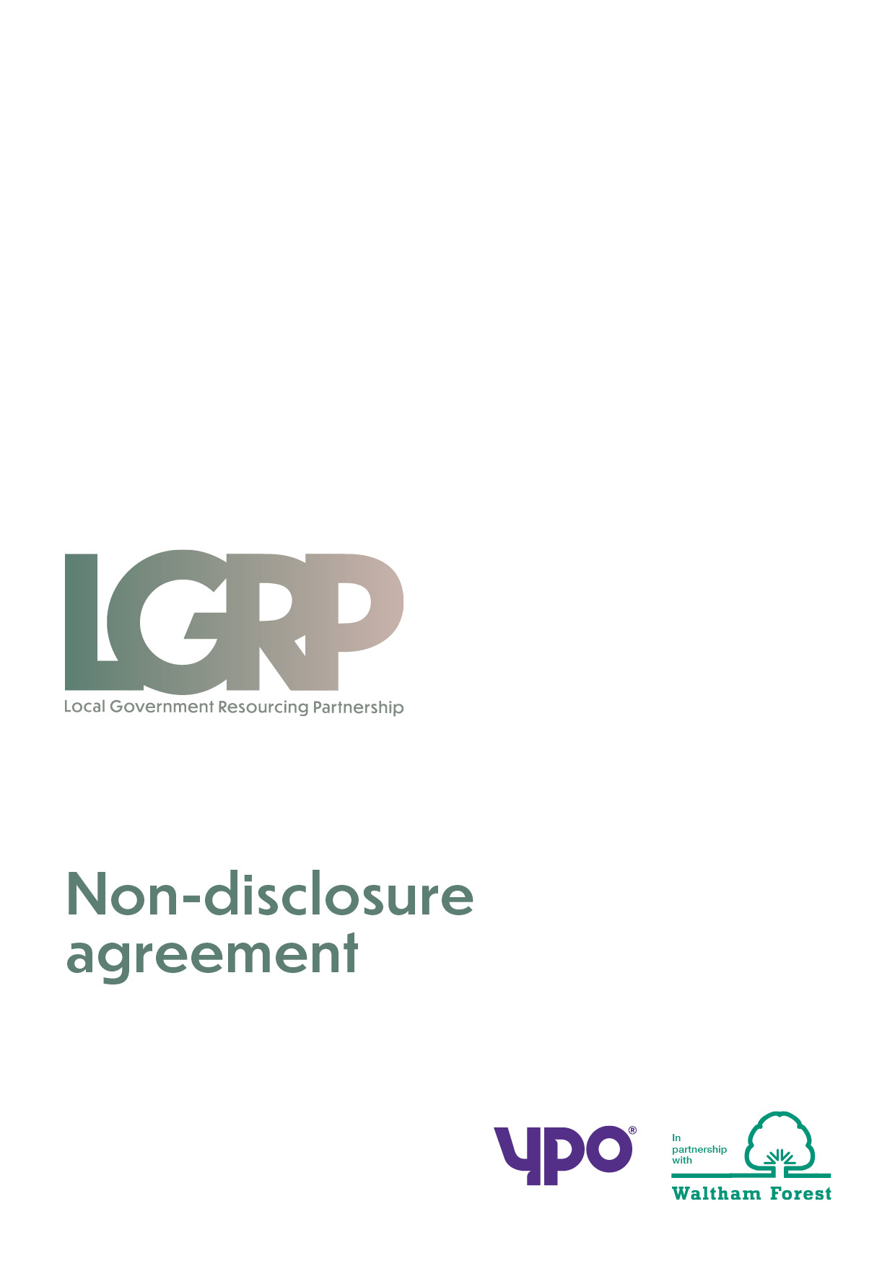
Customer Access Agreement

LGRP Framework (All Lots)

LONDON BOROUGH OF WALTHAM FOREST and YPO
Contract Reference: LGRP

Framework 10.11.2021 – 09.11.2023

Before conducting any activity under this LONDON BOROUGH OF WALTHAM FOREST & YPO framework, please complete this form and return it (by post, fax or email) to YPO.

Please read and review the statement below prior to signing this document:

AGREEMENT: I/we confirm that the organisation detailed below may participate in the above mentioned LONDON BOROUGH OF WALTHAM FOREST & YPO Framework Agreement, and that in doing so will act in accordance with the guidance and instructions set out in the relevant LONDON BOROUGH OF WALTHAM FOREST & YPO User Guide, and in accordance with the Public Contracts Regulations 2015.

I/we confirm that any guidance and/or template documentation provided to me will only be used in relation to this Framework and will only be used for other purposes where prior consent from LONDON BOROUGH OF WALTHAM FOREST & YPO has been given.

I/we also confirm that in consideration of LONDON BOROUGH OF WALTHAM FOREST & YPO acting in this capacity I/we authorise LONDON BOROUGH OF WALTHAM FOREST & YPO to make such arrangements with its’ suppliers relating to Retrospective Payments on Goods and/or Services, and to make such enquiries in relation to the 1% rebate on spend as detailed in the user guides and tender process.

Name:

Position:

Signature:

Date:

Name of Organisation:
Address:

Telephone:

E-mail:

Please return this form via email to lgrp@ypo.co.uk

